WEEK 5
Task 1
Aim : To find the maximum sum of a contiguous subarray within a given integer array
Algorithm :
- Initialize variables:
  - currentSum = nums[0]
  - maxSum = nums[0]
- Traverse the array from index 1 to n-1:
For each element nums[i]:
  - Update current sum:
currentSum = max(nums[i], currentSum + nums[i])
(Either start a new subarray or extend the previous one)
  - Update maximum sum:
maxSum = max(maxSum, currentSum)
- Return maxSum
Program :
class Solution {
public int maxSubArray(int[] nums) {
int currentSum = nums[0];
int maxSum = nums[0];

for (int i = 1; i < nums.length; i++) {
currentSum = Math.max(nums[i], currentSum + nums[i]);
maxSum = Math.max(maxSum, currentSum);
}

return maxSum;
}
}
Output :
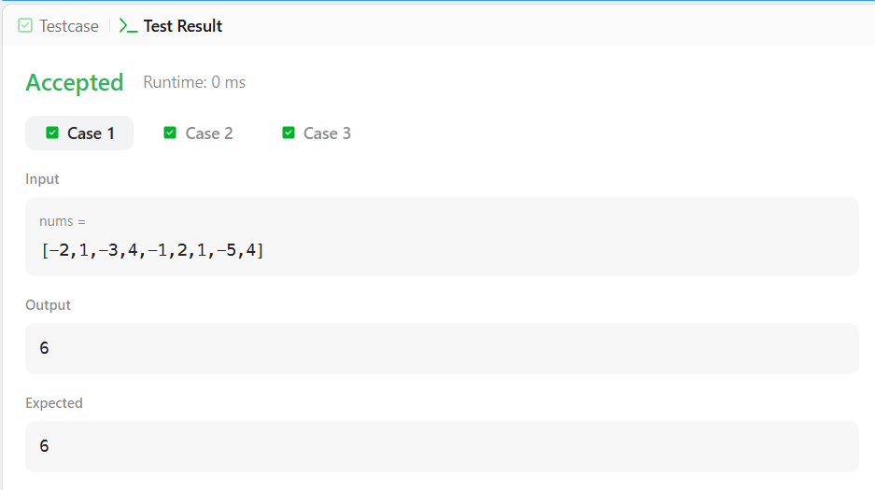

Result :
Thus to find To find the maximum sum of a contiguous subarray within a given integer array was executed successfully

TASK 2
Aim : To determine the number of contiguous segments of the chocolate bar such that The length of the segment The sum of the integers in that segment
Algorithm :
- Input:
  - Array s of size n
  - Integer d (birth day)
  - Integer m (birth month)
- Check Edge Case:
  - If n < m, return 0 (not enough squares).
- Initialize Variables:
  - count = 0
  - windowSum = 0
- Compute sum of first m elements:
  - Add elements from index 0 to m-1.
  - If windowSum == d, increment count.
- Slide the window from index m to n-1:
  - Add current element s[i]
  - Subtract element leaving window s[i-m]
  - If updated windowSum == d, increment count
- Return count
Program :
import java.util.*;

public class Solution {

public static int birthday(List<Integer> s, int d, int m) {
int count = 0;
int windowSum = 0;

if (s.size() < m) {
return 0;
}

for (int i = 0; i < m; i++) {
windowSum += s.get(i);
}

if (windowSum == d) {
count++;
}

for (int i = m; i < s.size(); i++) {
windowSum += s.get(i);
windowSum -= s.get(i - m);

if (windowSum == d) {
count++;
}
}

return count;
}

public static void main(String[] args) {
Scanner sc = new Scanner(System.in);

int n = sc.nextInt();
List<Integer> s = new ArrayList<>();

for (int i = 0; i < n; i++) {
s.add(sc.nextInt());
}

int d = sc.nextInt();
int m = sc.nextInt();

System.out.println(birthday(s, d, m));
}
}
Output :
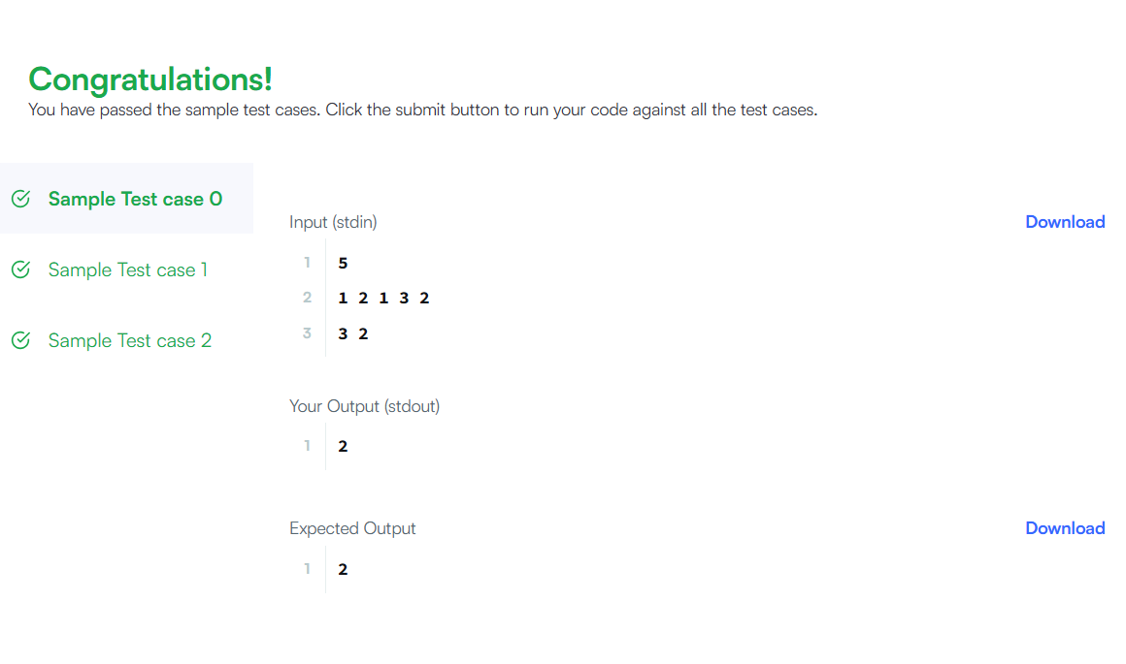
Result :
Thus To determine the number of contiguous segments of the chocolate bar such that The length of the segment The sum of the integers in that segment
Task 3 :
Aim : To find and print two values for a given integer array
Algorithm :
1. Read the array of size n.
2. For Maximum Subarray (Kadane’s Algorithm):
  - Initialize currentSum = arr[0], maxSubarray = arr[0].
  - For each element from index 1 to n-1:
    - currentSum = max(arr[i], currentSum + arr[i])
    - maxSubarray = max(maxSubarray, currentSum)
3. For Maximum Subsequence:
  - Add all positive elements.
  - If all elements are negative, take the maximum element.
- Print maxSubarray and maxSubsequence.

Program :
import java.util.*;
public class Solution {
public static int[] maxSubarray(int[] arr) {
int currentSum = arr[0];
int maxSubarray = arr[0];

for (int i = 1; i < arr.length; i++) {
currentSum = Math.max(arr[i], currentSum + arr[i]);
maxSubarray = Math.max(maxSubarray, currentSum);
}

int maxSubsequence = 0;
int maxElement = arr[0];

for (int num : arr) {
if (num > 0) {
maxSubsequence += num;
}
maxElement = Math.max(maxElement, num);
}

if (maxSubsequence == 0) {
maxSubsequence = maxElement;
}

return new int[]{maxSubarray, maxSubsequence};
}
public static void main(String[] args) {
Scanner sc = new Scanner(System.in);
int t = sc.nextInt();

while (t-- > 0) {
int n = sc.nextInt();
int[] arr = new int[n];

for (int i = 0; i < n; i++) {
arr[i] = sc.nextInt();
}

int[] result = maxSubarray(arr);
System.out.println(result[0] + " " + result[1]);
}
}
}

Output :

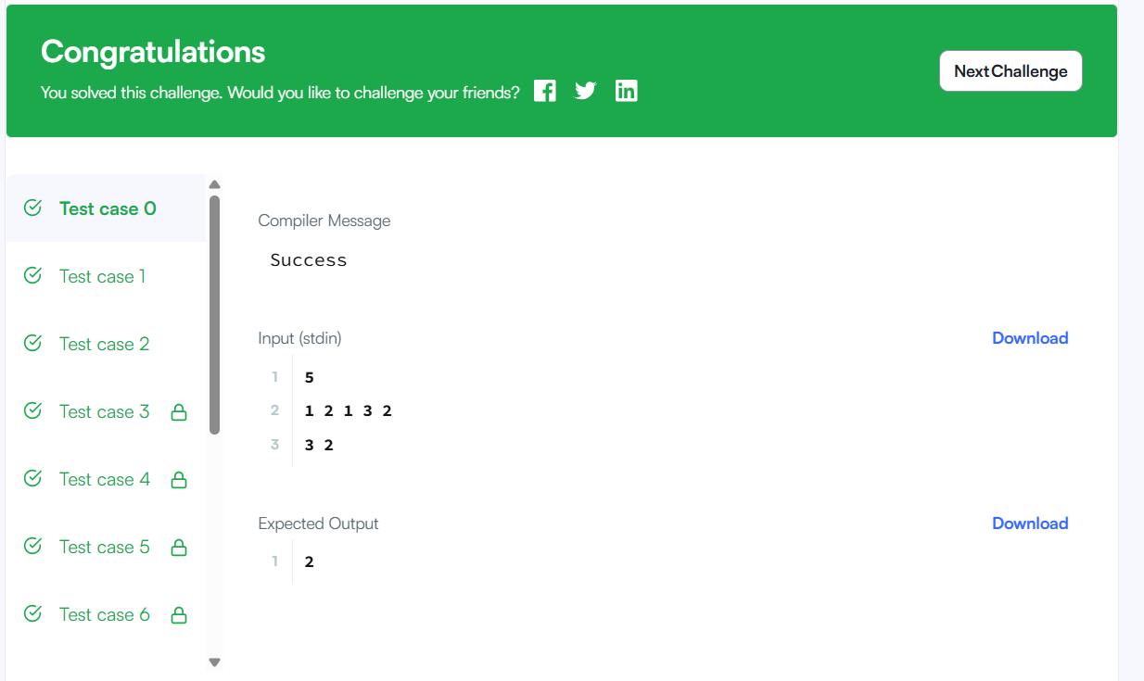
Result :
Thus To find and print two values for a given integer array was executed successfully.

Task 4 :
Aim : To find the maximum possible sum of a non-empty subarray in a circular integer array.
Algorithm :
1. Initialize:
totalSum = 0
currentMax = 0, maxSum = nums[0]
currentMin = 0, minSum = nums[0]
2. Traverse the array:
Add element to totalSum
Update maximum subarray:
currentMax = max(num, currentMax + num)
maxSum = max(maxSum, currentMax)
Update minimum subarray:
currentMin = min(num, currentMin + num)
minSum = min(minSum, currentMin)
- .If maxSum < 0
Return maxSum
- Otherwise return:

Program:
class Solution {
public int maxSubarraySumCircular(int[] nums) {
int totalSum = 0;
int currentMax = 0, maxSum = nums[0];
int currentMin = 0, minSum = nums[0];

for (int num : nums) {
totalSum += num;

currentMax = Math.max(num, currentMax + num);
maxSum = Math.max(maxSum, currentMax);

currentMin = Math.min(num, currentMin + num);
minSum = Math.min(minSum, currentMin);
}

// If all elements are negative
if (maxSum < 0) {
return maxSum;
}

return Math.max(maxSum, totalSum - minSum);
}
}

Output :
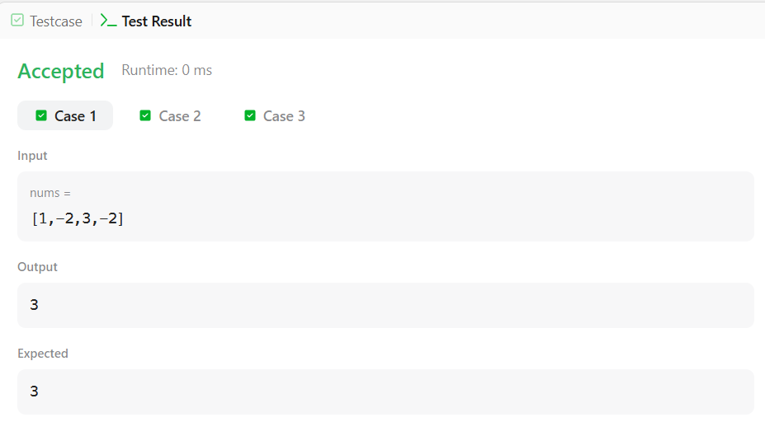
Result :
Thus To find the maximum possible sum of a non-empty subarray in a circular integer array was executed successfully.

Task 5
Aim : To write a Java 8 program that converts time from 12-hour AM/PM format to 24-hour (military) format according to standard time conversion rules.
Algorithm :
1. Start
2. Read the time string s (in hh:mm:ssAM/PM format).
3. Extract the hour (first two characters).
4. Extract AM/PM (last two characters).
5. If AM:
If hour = 12, change hour to 00.
6. If PM:
If hour ≠ 12, add 12 to hour.
7. Keep minutes and seconds unchanged.
8. Combine the updated hour with minutes and seconds.
9. Print the result (24-hour format).
10 Stop.
Program :

public class Solution {

public static String timeConversion(String s) {
String period = s.substring(s.length() - 2); // AM or PM
int hour = Integer.parseInt(s.substring(0, 2));
String rest = s.substring(2, 8); // :MM:SS

if (period.equals("AM")) {
if (hour == 12) {
hour = 0;
}
} else { // PM
if (hour != 12) {
hour += 12;
}
}

return String.format("%02d", hour) + rest;
}

public static void main(String[] args) {
String input = "07:05:45PM";
System.out.println(timeConversion(input)); // Output: 19:05:45
}
}

Output :
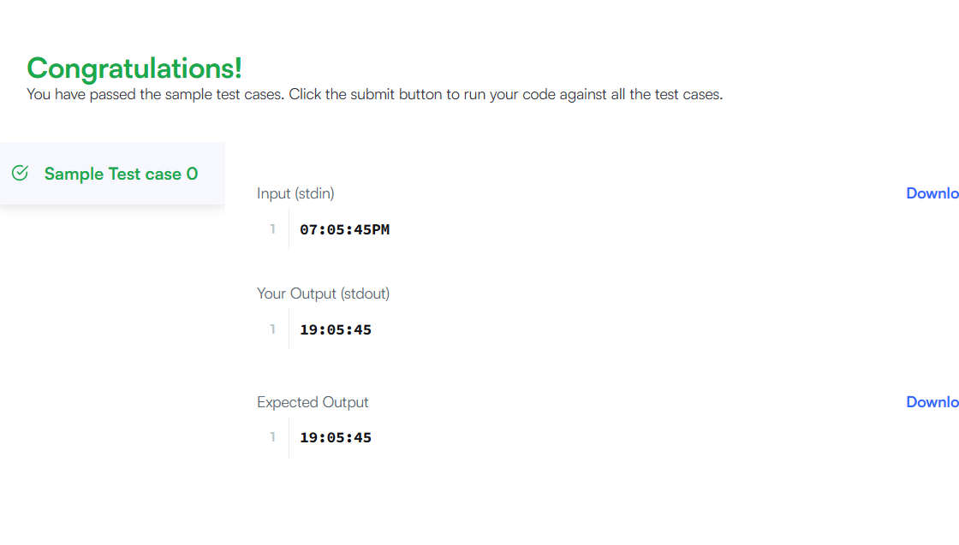
Result : Thus to write a Java 8 program that converts time from 12-hour AM/PM format to 24-hour (military) format according to standard time conversion rules was executed successfully

Task 6

Aim : To write a Java program that moves all zeros in an array to the end while maintaining the relative order of non-zero elements.

Algorithm :
- Start
- Take the input array nums.
- Initialize a variable index = 0.
- Traverse the array from start to end.
- If the current element is not zero:
Place it at position index.
Increment index.
- After traversal, fill remaining positions in the array with 0.
- Print the modified array.
- Stop.

Program :
public class Solution {
public void moveZeroes(int[] nums) {
int index = 0;

for (int i = 0; i < nums.length; i++) {
if (nums[i] != 0) {
nums[index] = nums[i];
index++;
}
}
while (index < nums.length) {
nums[index] = 0;
index++;
}
}
}

Output :
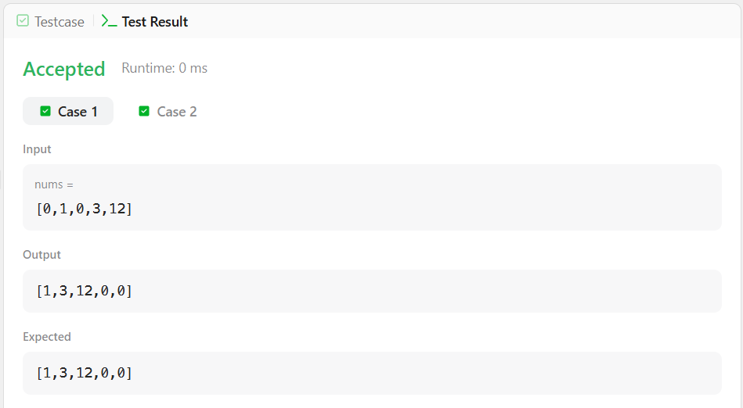

Result : Thus to write a Java program that moves all zeros in an array to the end while mainta ining the relative order of non-zero elements

